**Exercise 1: Setting Up JUnit**

Scenario: You need to set up JUnit in your Java project to start writing unit tests.

**Codes:**

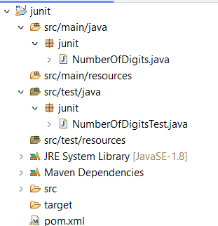

**NumberOfDigits.java:**

**package** junit;

**public** **class** NumberOfDigits {

**public** **static** **int** digitCount(**int** num) {

num=Math.*abs*(num);

**if**(num==0)**return** 1;

**int** count=0;

**while**(num!=0) {

num/=10;

count++;

}

**return** count;

}

}

**NumberOfDigitsTest.java:**

**package** junit;

**import** org.junit.Test;

**import** **static** org.junit.Assert.*;

**public** **class** NumberOfDigitsTest {

@Test

**public** **void** testPositiveNumber() {

*assertEquals*(5,NumberOfDigits.*digitCount*(12345));

}

@Test

**public** **void** testNegativeNumber() {

*assertEquals*(3,NumberOfDigits.*digitCount*(-404));

}

@Test

**public** **void** testZero() {

*assertEquals*(1,NumberOfDigits.*digitCount*(0));

}

}

**Output:**

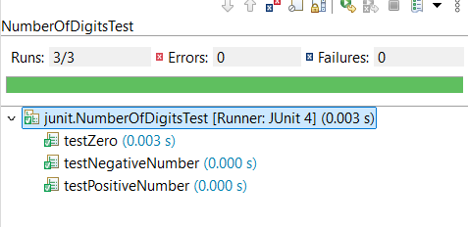

**Exercise 3: Assertions in JUnit**

Scenario: You need to use different assertions in JUnit to validate your test results.

**Code:**

**AssertionsTest.java:**

**package** junit;

**import** org.junit.Test;

**import** **static** org.junit.Assert.*;

**public** **class** AssertionsTest {

@Test

**public** **void** testAssertions() {

// Assert equals

*assertEquals*(5, 2 + 3);

// Assert true

*assertTrue*(5 > 3);

// Assert false

*assertFalse*(5 < 3);

// Assert null

*assertNull*(**null**);

// Assert not null

*assertNotNull*(**new** Object());

}

}

**Output:**

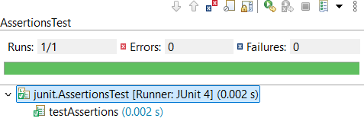

**Exercise 4: Arrange-Act-Assert (AAA) Pattern, Test Fixtures, Setup and Teardown Methods in JUnit**

Scenario: You need to organize your tests using the Arrange-Act-Assert (AAA) pattern and use setup and teardown methods.

**Codes:**

**SumOfDigits.java:**

**package** junit;

**public** **class** SumOfDigits {

**public** **int** digitSum(**int** num) {

**int** sum=0;

num=Math.*abs*(num);

**while**(num>0) {

sum+=num%10;

num/=10;

}

**return** sum;

}

}

**SumOfDigitsTest.java:**

**package** junit;

**import** org.junit.Test;

**import** **static** org.junit.Assert.*;

**import** org.junit.Before;

**import** org.junit.After;

**public** **class** SumOfDigitsTest {

**private** SumOfDigits sumTest;

@Before

**public** **void** setUp() {

sumTest=**new** SumOfDigits();

System.***out***.println("Setup executed");

}

@After

**public** **void** tearDown() {

sumTest=**null**;

System.***out***.println("Teardown executed");

}

@Test

**public** **void** testSumOfDigitsPositive() {

*assertEquals*(6,sumTest.digitSum(123));

}

**public** **void** testSumOfDigitsNegative() {

*assertEquals*(15,sumTest.digitSum(-456));

}

**public** **void** testSumOfDigitsZero() {

*assertEquals*(0,sumTest.digitSum(0));

}

}

**Output:**

